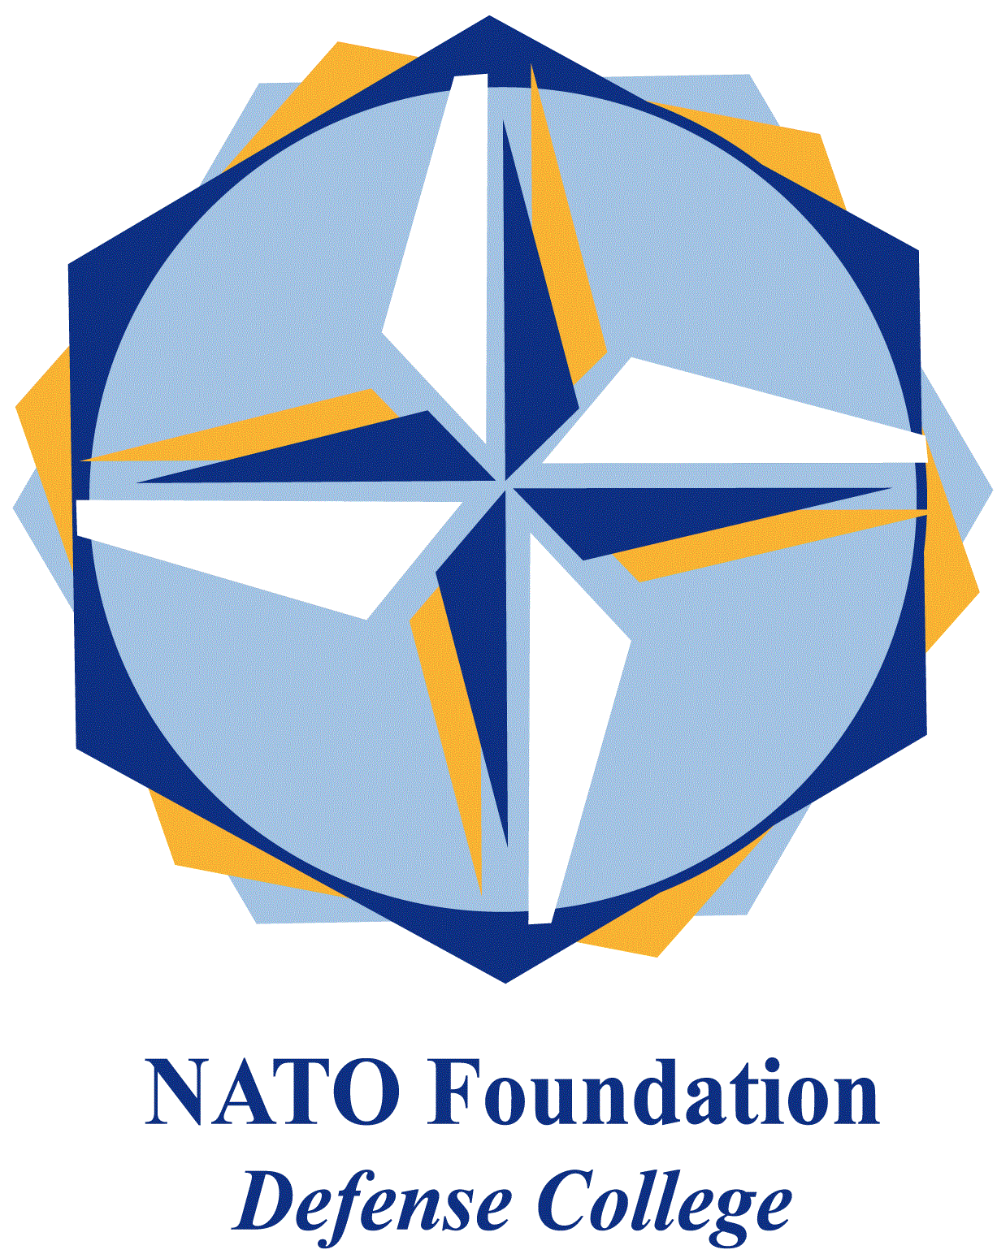
NATO DEFENSE COLLEGE FOUNDATION
STRATEGIC TRENDS
February 2016
BALKANS
Montenegro’s Accession Talks: a good day for the Balkans?
“Montenegro’s membership will demonstrate to all those who aspire to membership that if a country delivers, so does NATO. Our door remains open”. This quotation is part of the letter that the NATO Secretary General Jens Stoltenberg sent on Thursday 3 December 2015 to three Montenegrin newspapers, welcoming the invitation to the country to start accession talks. The decision was in fact taken the previous day, when the council of the foreign ministers of the alliance decided unanimously to take this important step regarding the relation between NATO and Montenegro.
This month, precisely on Monday 15th, the accession talks started in Brussels, formalizing the opening of the process hailed as “historic” by SG Stoltenberg. On the one hand, the beginning of the diplomatic talks for accession represents the milestone of a ten-year bilateral process, on the other it entails much wider regional and global political consequences.
The relation between NATO and Montenegro started in 2006, when Podgorica officially declared its independence from Belgrade. Once the Montenegrin Parliament adopted the declaration of independence, the invitation to join the Partnership for Peace was almost immediate. On December 2006 Montenegro became a member of the PfP. Only two years later (2008) Montenegro started an Individual Partnership Action Plan that lead the country in 2010 to join the Membership Action Plan. If the ongoing talks would unfold positively, an Accession Protocol would be signed and it will quickly bring Montenegro to become the 29th member country of the alliance.
For Montenegro, the accession at the alliance will undoubtedly represent a step forward for both its political and economic standing. Joining NATO would be considered the formal recognition of years of deep co-operation with western countries, and it will hopefully lead to a future integration in the European Union. This stabilisation would probably boost Montenegro’s economy too, because it depends mostly on European tourism.
As outlined by Stoltenberg, this decision also proves that NATO did not abandon the aim of including the whole European space in the alliance. This is especially crucial in regards to the western Balkans region that represents the south-eastern flank of the alliance and that is exposed to growing tensions. Reaffirming its role in the Balkans, NATO may represent a stabilization element in facing the risk of jihadist radicalization in the region, something that is acutely perceived by local governments.
Furthermore, Montenegro’s accession to NATO was a message for Russia. As told by Foreign Minister Lavrov in 2014, Moscow will consider any further expansion of the alliance in the Balkans as a provocation. The fact that Montenegro would be the first Orthodox-majority country to join NATO, combined with the historical bonds that tie Podgorica and Belgrade, will probably constitute the main problem for the ongoing process of accession.
Some analysts also think that Russia has influenced the anti-corruption demonstrations (supported by the national Orthodox church) held last October and aimed at Dukanovic’s government. Future elections in Montenegro, scheduled for October 2016, could change the actual domestic scenario, putting into question Montenegro’s accession and leaving the country open to undue external influence.

